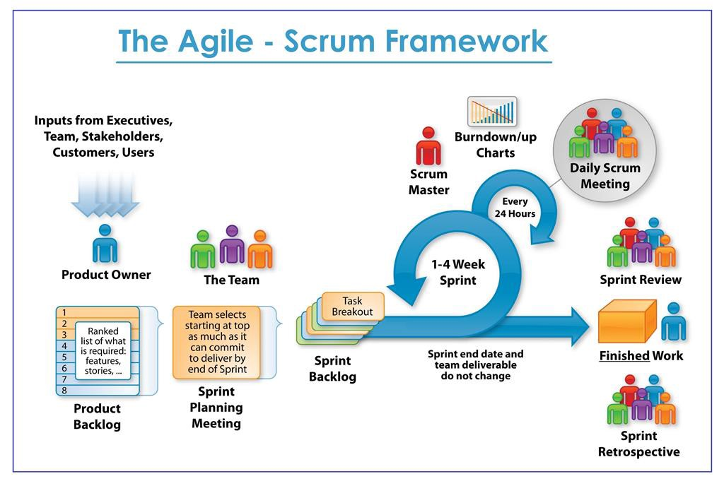

**Product Owner**

* **Role**: Manages the product backlog, prioritizes items based on business value, and ensures the team delivers maximum value.
* **Azure Boards**: The Product Owner will primarily work within the **Boards** and **Backlogs** sections.

**The Team**

* **Role**: A cross-functional group responsible for delivering the product increment.
* **Azure Boards**: Team members will use Boards to track and update their tasks.

**Product Backlog**

* **Definition**: A prioritized list of work items (user stories, bugs, features).
* **Azure Boards**:
  + Navigate to **Boards** > **Backlogs**.
  + Add new work items using the plus icon (+).
  + Prioritize items by dragging and dropping them into the desired order.

**Sprint Planning Meeting**

* **Objective**: Define what can be delivered in the upcoming sprint and how that work will be achieved.
* **Azure Boards**:
  + In the **Boards** section, navigate to **Sprints**.
  + Create a new sprint or select an existing one.
  + Move items from the product backlog to the sprint backlog.

**Sprint Backlog**

* **Definition**: A list of tasks the team commits to completing in a sprint.
* **Azure Boards**:
  + In **Sprints**, add work items to the current sprint.
  + Break down work items into tasks if necessary.

**Finished Work**

* **Definition**: Completed work items that meet the Definition of Done (DoD).
* **Azure Boards**:
  + Move work items to the **Done** column on the board.
  + Ensure all acceptance criteria are met.

**Sprint Review**

* **Objective**: Demonstrate the completed work to stakeholders and gather feedback.
* **Azure Boards**:
  + Use **Dashboards** to create visual summaries of the sprint’s progress and completed work.
  + Share the dashboard during the review meeting.

**Sprint Retrospective**

* **Objective**: Reflect on the sprint and identify ways to improve.
* **Azure Boards**:
  + Use **Boards** or **Wikis** to document the retrospective notes and action items.

**Daily Scrum Meeting**

* **Objective**: Synchronize the team’s activities and plan for the next 24 hours.
* **Azure Boards**:
  + Use the **Boards** section to update work item statuses.
  + Team members can check their assigned tasks and progress.

**Scrum Master**

* **Role**: Facilitates Scrum ceremonies, removes impediments, and ensures the team follows Agile practices.
* **Azure Boards**:
  + Manages the workflow, assists with board configuration, and ensures the team adheres to the Scrum process.

**Burndown/Burnup Chart**

* **Burndown Chart**: Shows the amount of work remaining in a sprint.
* **Burnup Chart**: Shows work completed over time against the total work.
* **Azure Boards**:
  + Navigate to **Dashboards**.
  + Add a new widget for **Sprint Burndown** or **Sprint Burnup**.

**Example Workflow in Azure Boards**

1. **Product Owner** creates and prioritizes work items in the product backlog.
2. **Sprint Planning Meeting**:
   * The team and Product Owner discuss which items to include in the next sprint.
   * Items are moved from the product backlog to the sprint backlog.
3. **Daily Scrum Meetings**:
   * Team members update their progress on the board.
   * Discuss blockers and plan for the day.
4. **Throughout the Sprint**:
   * Team members work on tasks, updating the board as they progress.
5. **Sprint Review**:
   * Demonstrate completed work using the **Boards** and **Dashboards**.
6. **Sprint Retrospective**:
   * Reflect on the sprint and document improvement actions.
7. **Scrum Master** ensures the process runs smoothly and addresses any issues.

**Setting Up Azure Boards for Scrum**

1. **Create the Project**:
   * Go to Azure DevOps and create a new project or select an existing one.
2. **Configure the Process**:
   * Choose **Scrum** as the process template when creating the project.
   * Go to **Project Settings** > **Process** to manage work item types and workflows.
3. **Set Up Iterations**:
   * Go to **Project Settings** > **Project Configuration**.
   * Define your sprint cadence and create iteration paths.
4. **Add Users**:
   * Go to **Project Settings** > **Teams**.
   * Add team members and assign roles (Product Owner, Scrum Master, Developers).
5. **Create Work Items**:
   * Use **Boards** > **Backlogs** to create and prioritize work items.
6. **Plan Sprints**:
   * In **Boards** > **Sprints**, assign work items to the current sprint.
7. **Track Progress**:
   * Use the board to track the status of work items.
   * Set up **Dashboards** for visual progress tracking, including burndown charts.